Papers written by Australian Maths Software

SEMESTER ONE

MATHEMATICS SPECIALIST
REVISION 1
UNIT 3

2016

SOLUTIONS

Section One
1. (10 marks)
(a)
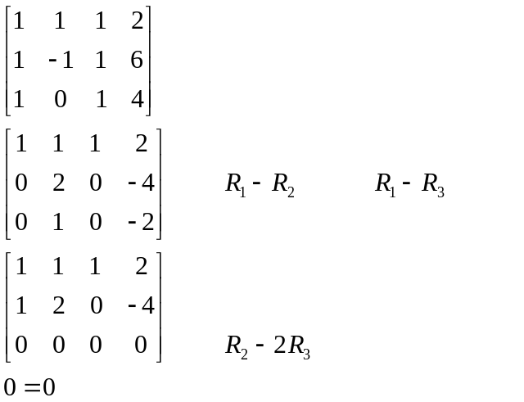
✓
✓
✓
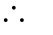There are an infinite number of solutions.
None of the planes are parallel.
There are either two or three identical planes or the three planes intersect in a common line.
✓
None of the planes have identical/equivalent equations so the three planes meet in a common line. (4)
✓
(b) Two of the planes are parallel. Therefore there is no intersection.
✓
are parallel (2)
(c)
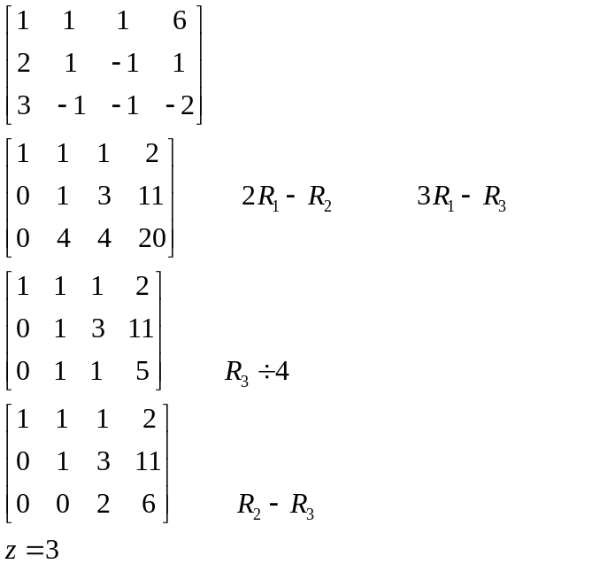
✓
✓
✓
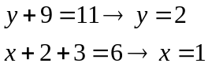
✓
The point of intersection is (1, 2, 3) (4)
2. (6 marks)
(a) 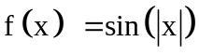 ✓✓ (2)
(b) 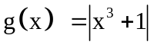 ✓✓ (2)
(c) 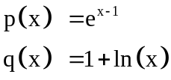 (2)
✓
✓

3. (13 marks)
(a) 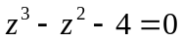
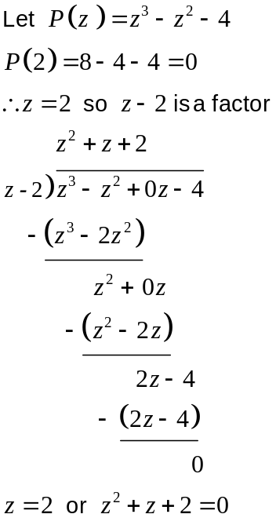
✓
✓
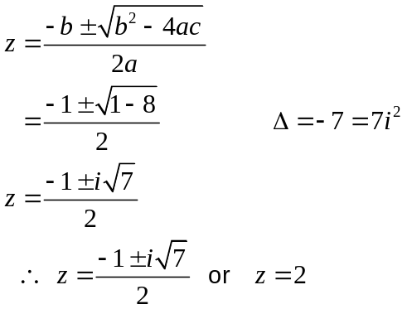
✓✓

(4)

(b) 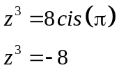
✓✓

✓
(3)

(c) (i)
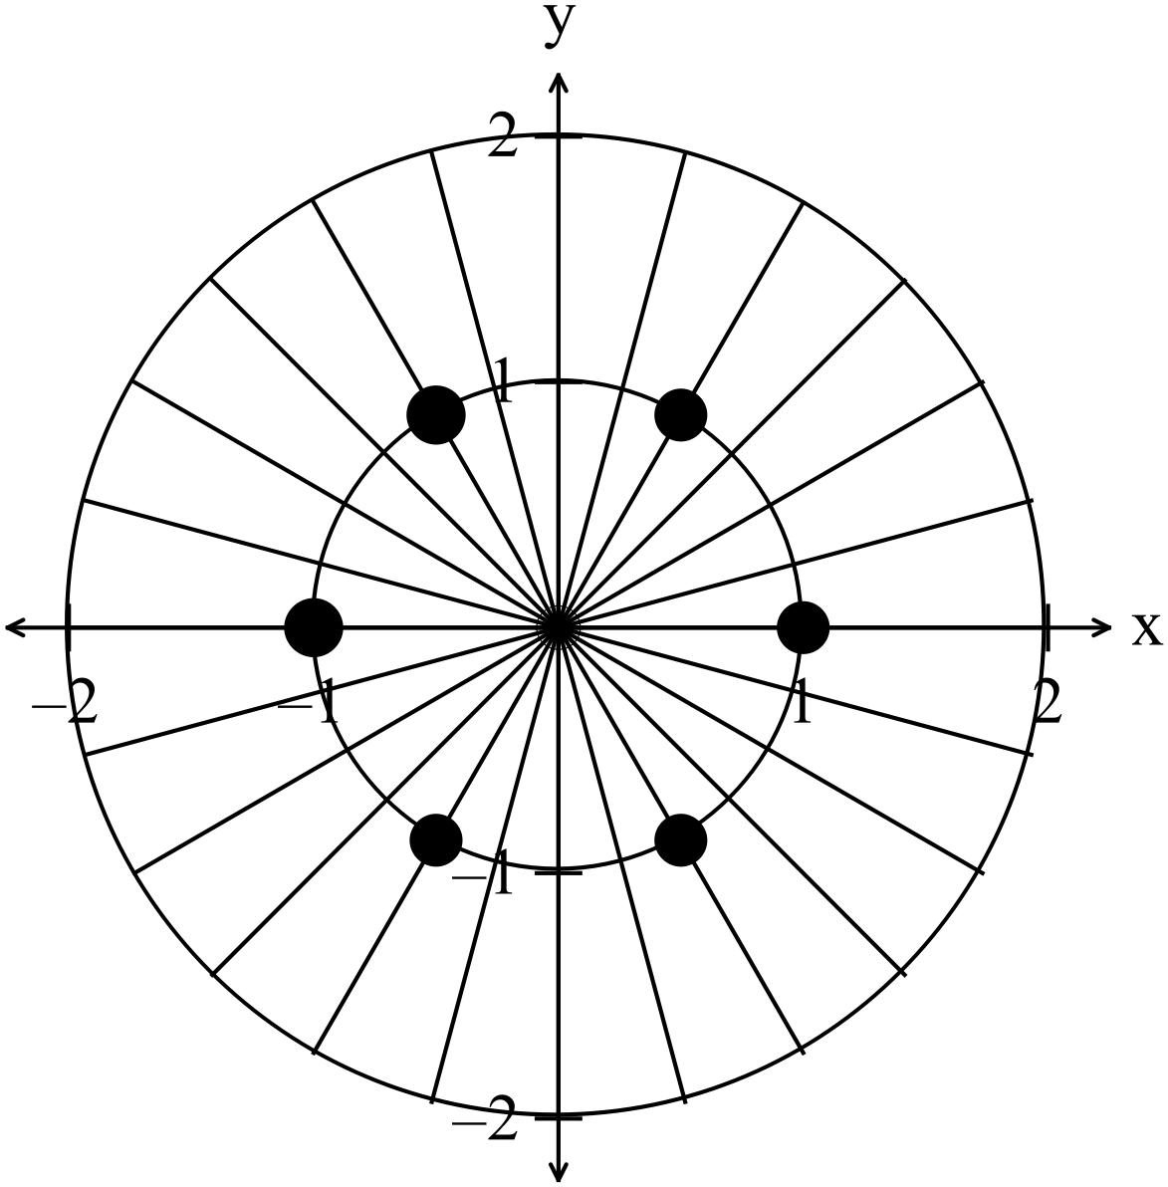
✓✓ -1 per error
(2)

(ii) 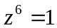
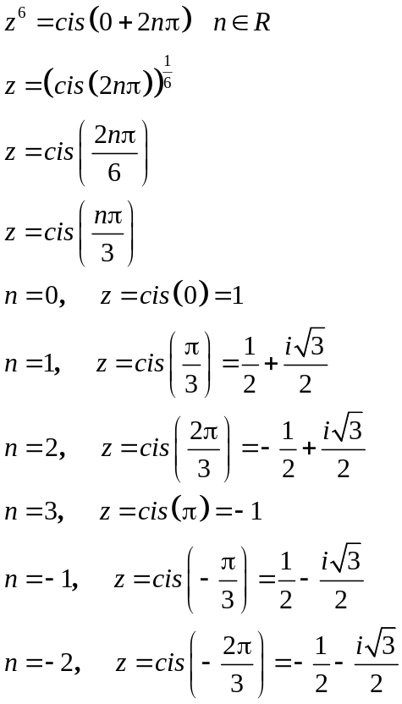 -1 per error (4)
✓
✓
✓
✓
4. (8 marks)
(a) 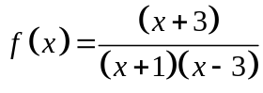
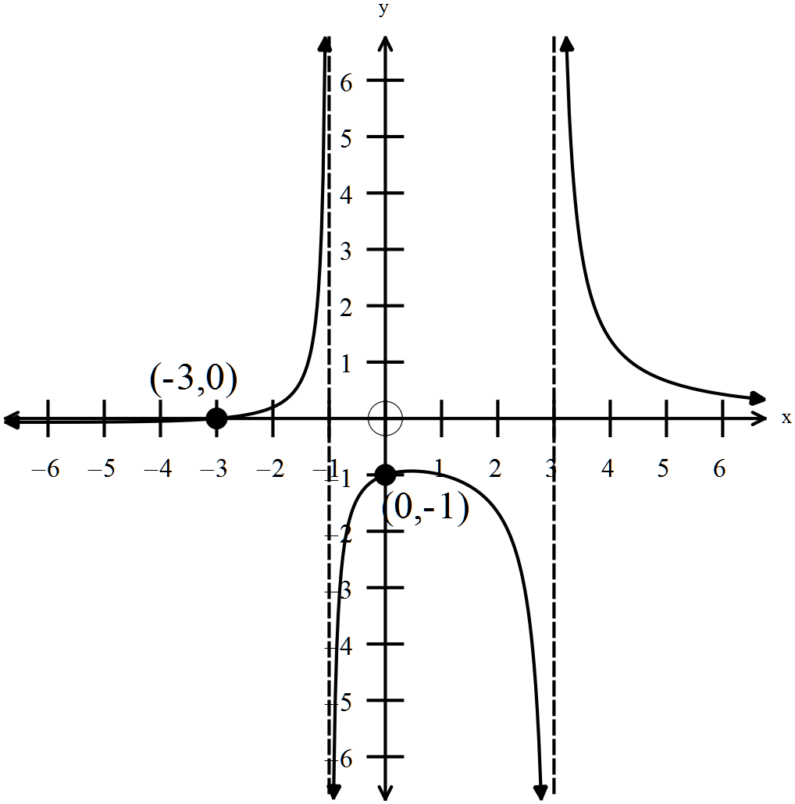
✓
Vertical asymptotes at 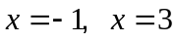
✓
✓
intercept at 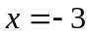
✓
intercept at 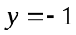
General shape – maximum turning point (w/0 cutting x axis); limits as 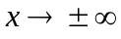;
✓
limits about asymptotes -1/error (4)

(b)
✓
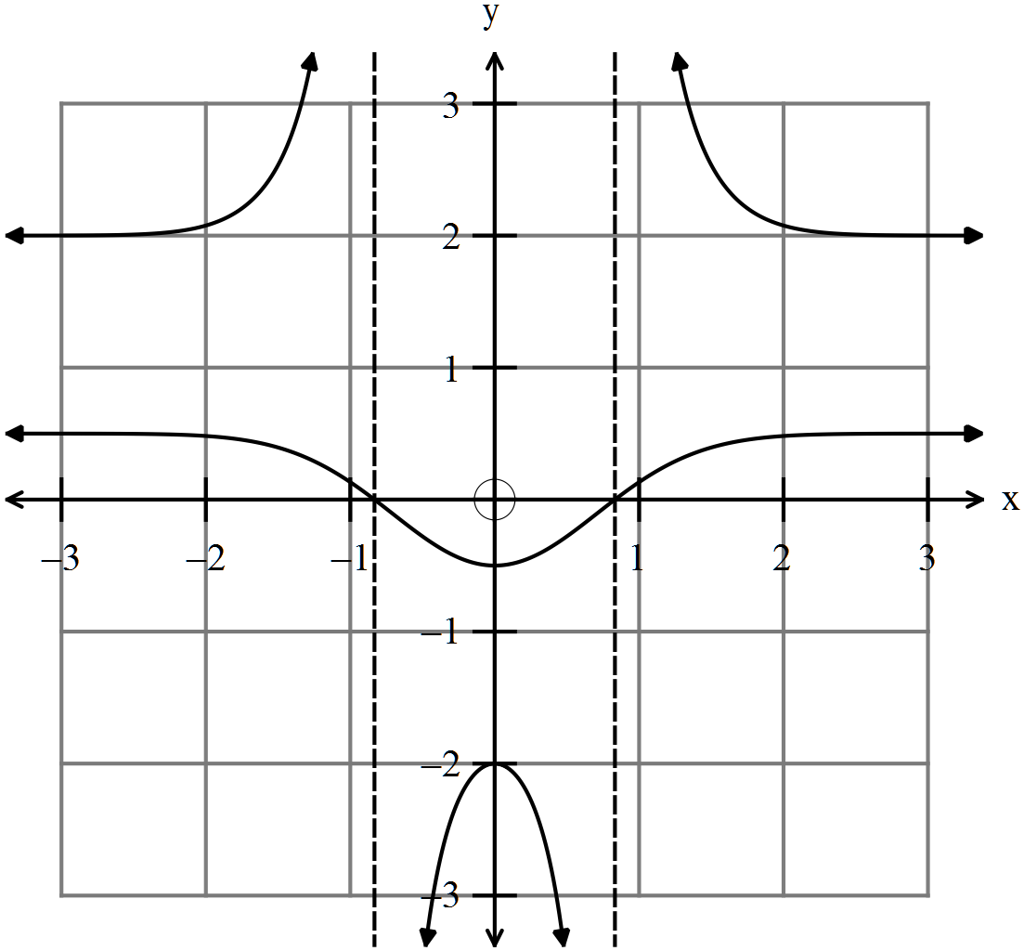
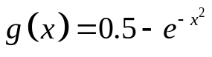
✓
✓
✓
(4)
5. (13 marks)
(a) 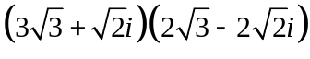. 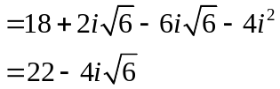 (3)
✓✓

✓

(b)
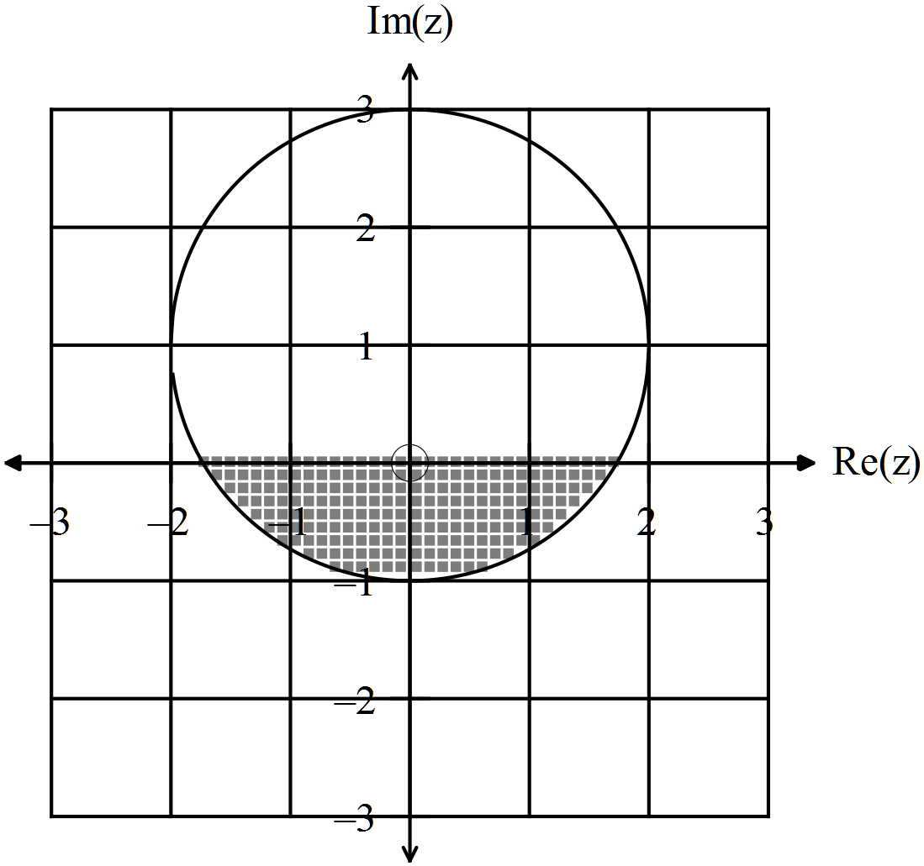
✓✓✓ -1/error

(3)
(c)
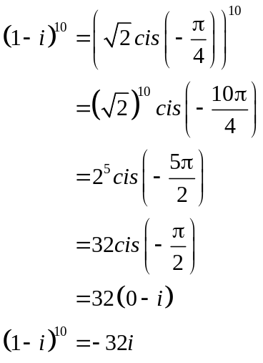 (2)
✓

✓

(d) 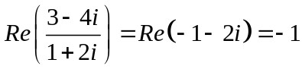
✓ ✓ (2)

(e) (i) 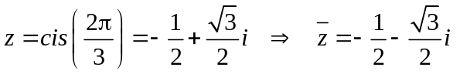 ✓ (1)
(ii) 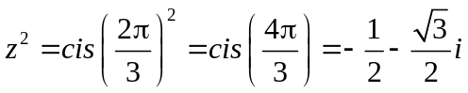 ✓ (1)

(ii) 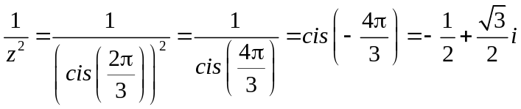 ✓ (1)

END OF SECTION ONE
Section Two
6. (6 marks)
(a) 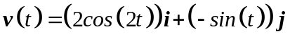
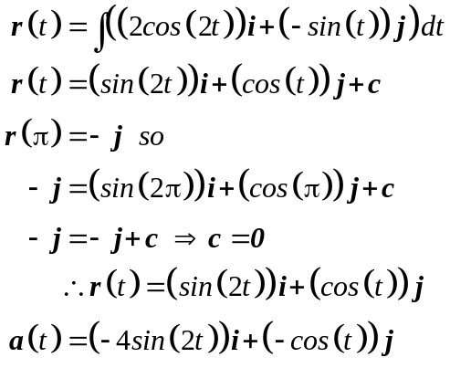
✓

✓

✓

(3)
(b) 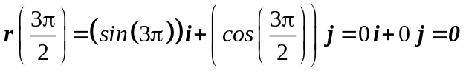 ✓
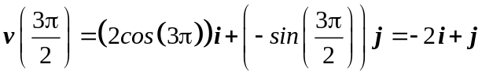 ✓ (2)
(c) Show that 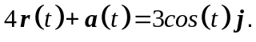
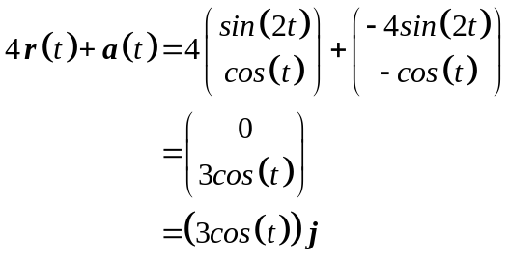✓ (1)

7. (20 marks)
(a) 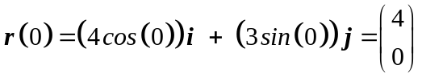 ✓
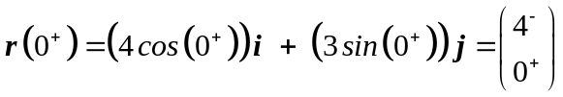 ✓

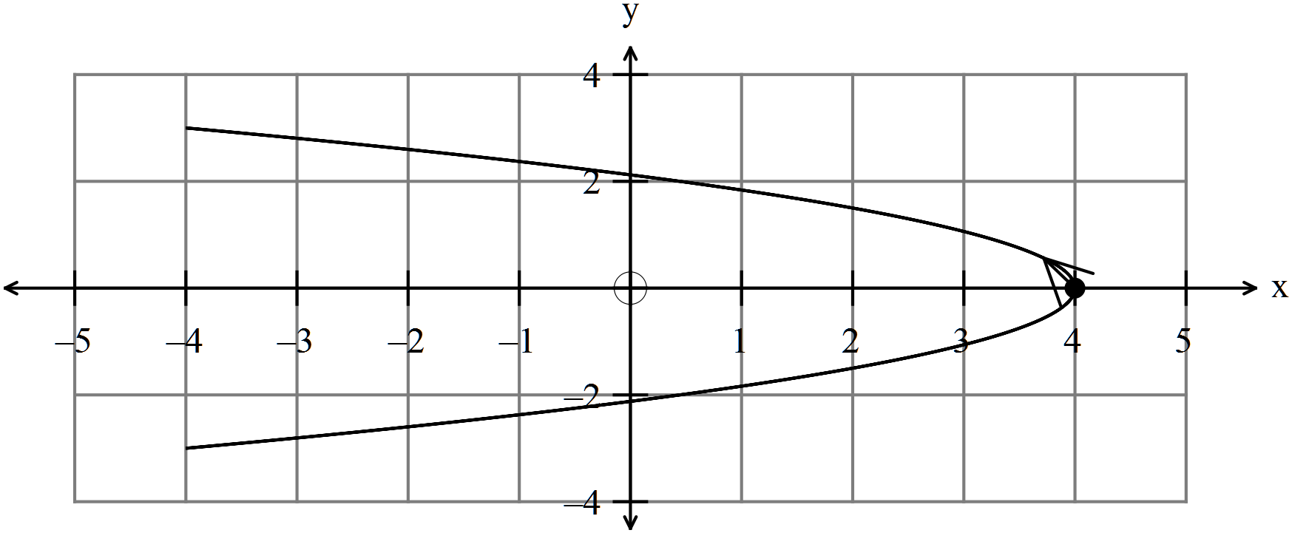✓
(3)
(b) 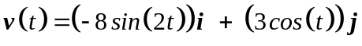 ✓✓
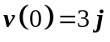 ✓
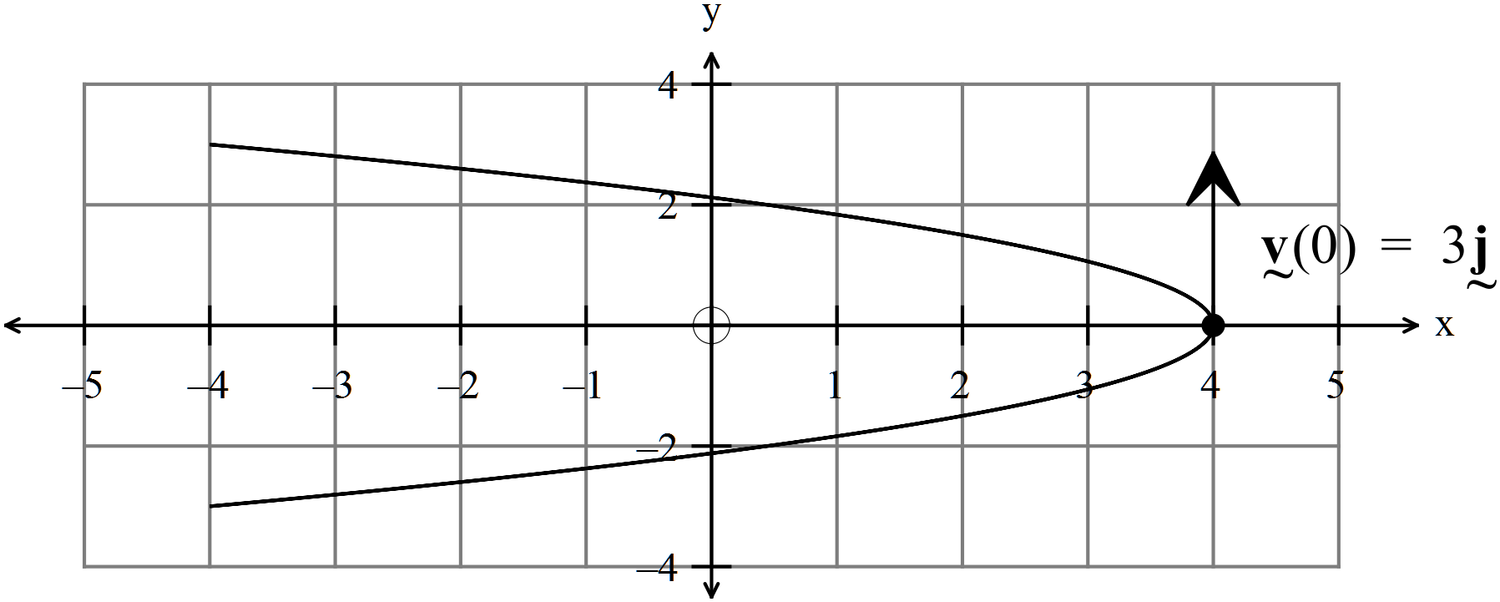✓
(4)

(c) 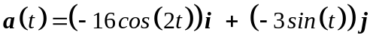 ✓✓ (2)
(d) 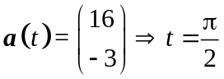 ✓
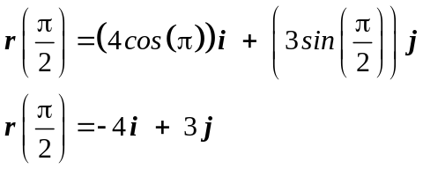
✓

(2)
(e)
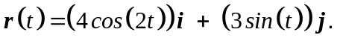
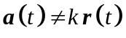 ✓
as 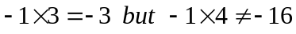 ✓ (2)

(f) If 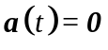 then 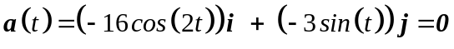
✓

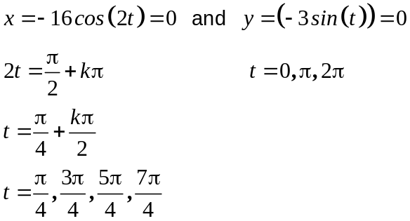
✓

✓

✓

The x and y coordinates are never zero at the same time so 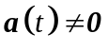 (4)
(g) 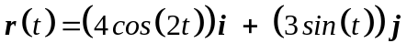
✓

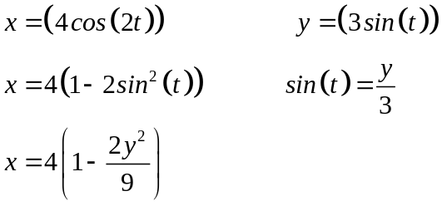
✓

✓

(3)
8. (10 marks)
(a)
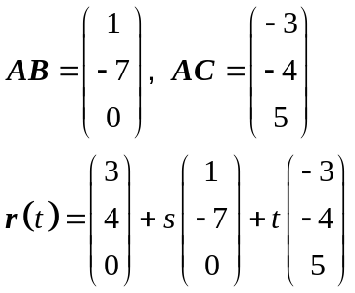
There are alternative answers as they can also use BC as a direction vector and then any of the points A,B or C for the equation.
✓

✓

(2)
(b) 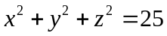 ✓✓ (2)
(c) (i) 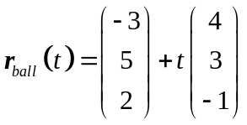
✓

Hits the ground at 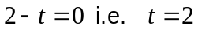 seconds ✓ (2)
(ii) 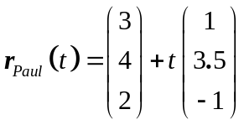
✓

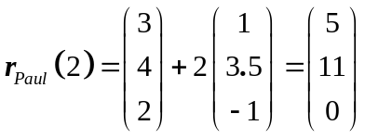
✓

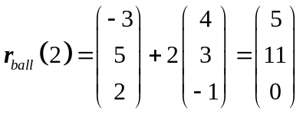
✓

Both Paul and the ball are at the same point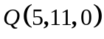 at ground level
when 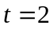, so Paul catches the ball. (3)
(ii) 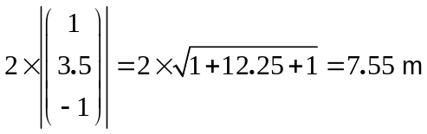 (1)
✓

9. (6 marks)
(a) (i) 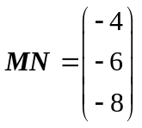
✓

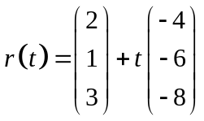 (2)
✓

✓

(ii)
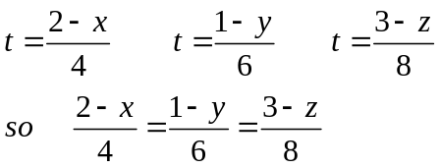
✓

(2)
(b) 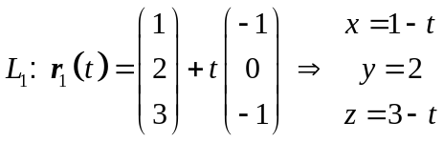
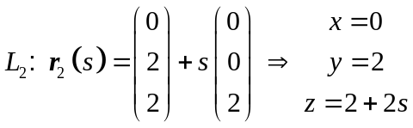
It can be seen that 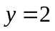. If 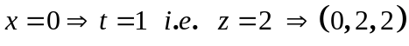
If 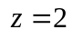 then 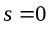which does not contradict the and values and gives
✓ logic

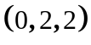.
✓

Yes, the lines intersect, and do so at .
(2)

10. (9 marks)

(a) 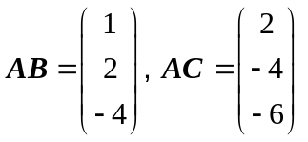
✓

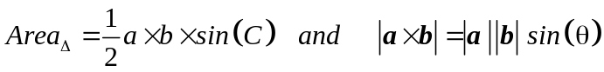
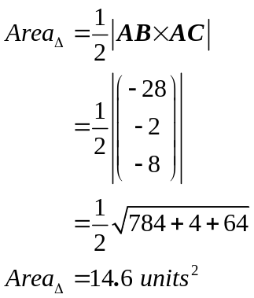
✓

✓

✓

(4)
(b) 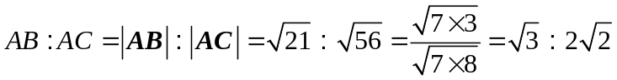 (2)
✓

✓

✓

(c) 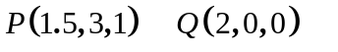
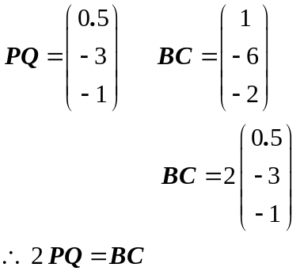
✓

✓

Therefore 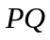 is parallel to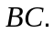 (3)

11. (13 marks)
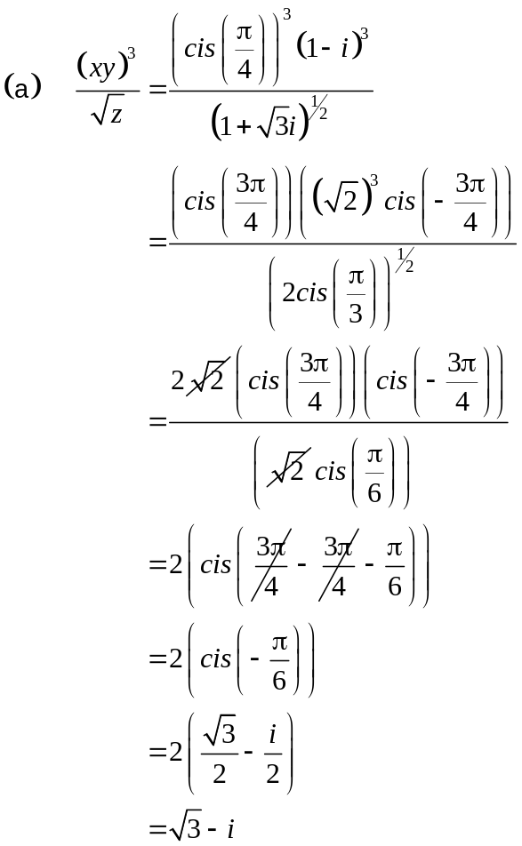
✓

✓

✓

✓

(4)

(b) 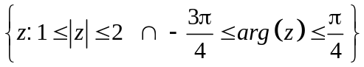 ✓ correct inequalities (3)
✓

✓

(c) (i) Given 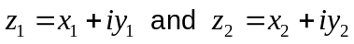 show that 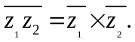
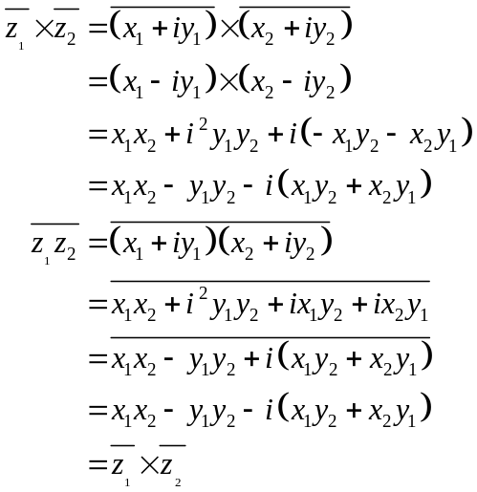
✓

✓

✓

(3)
(ii) 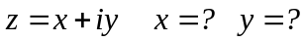
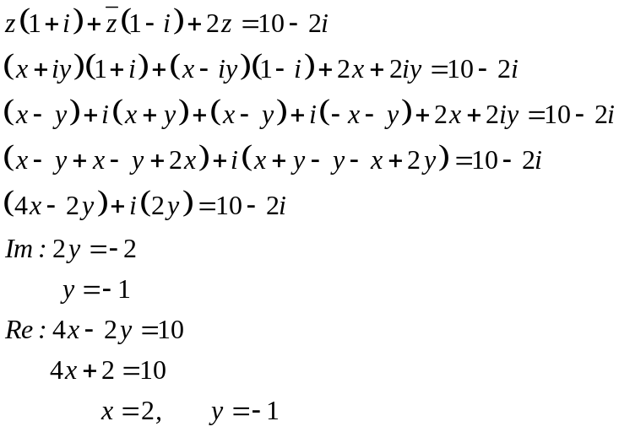
✓

✓

✓

(3)

12. (6 marks)

(a) 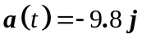
✓

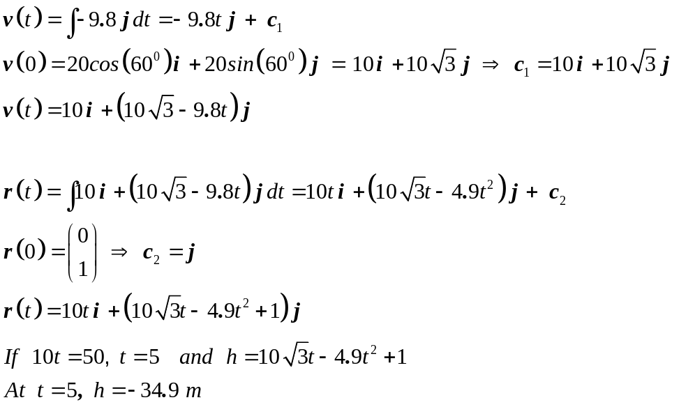
✓

✓

✓

This means the ball is not in flight for five seconds so Tom could not have
✓

kicked the ball through the window.
(4)

(b) 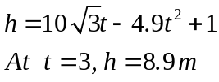
✓

The ball was still in flight so the deputy may have seen it.
(1)
13. (14 marks)
(a) (i) 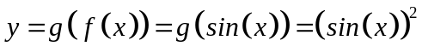 (1)
✓

(ii)
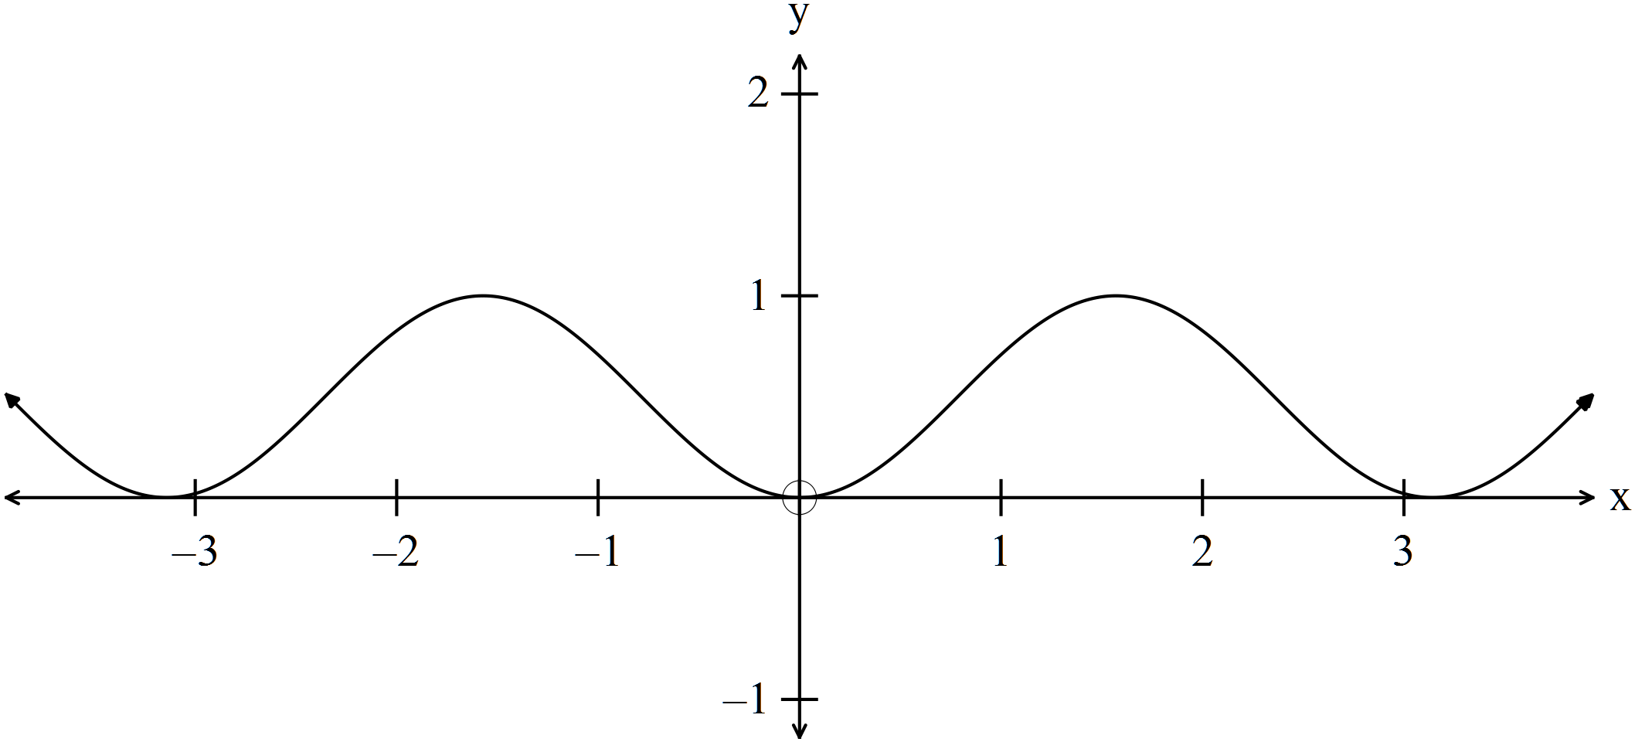
✓✓✓ -1/error

(3)
(iii) 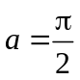 ✓✓ (2)

(iv)
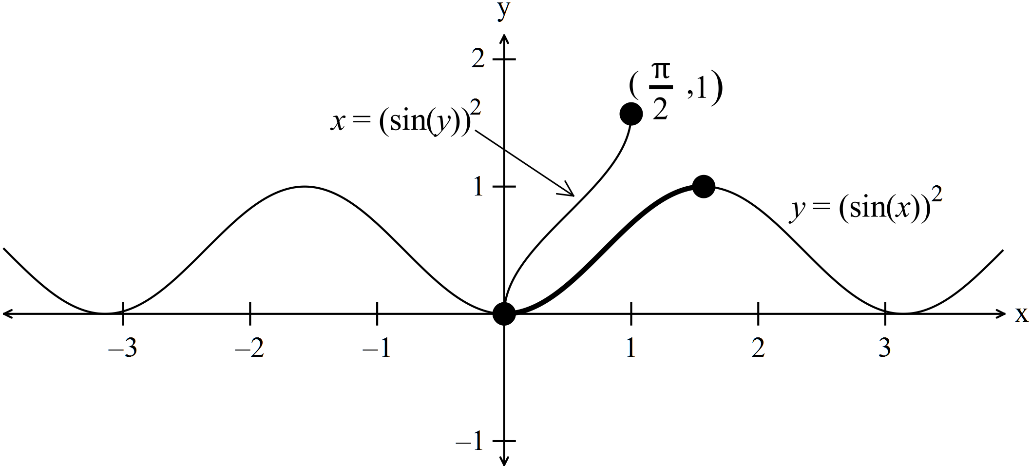
✓✓
✓

(2)
(b) (i) 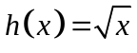
✓ must have restricted domain

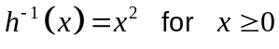 (1)
(ii) 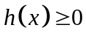 (1)
✓
✓

(c) 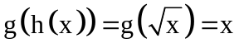 ✓
Defined on 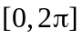 ✓ (2)

(d) (i)
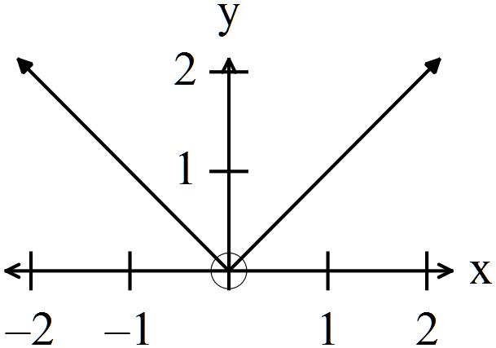
✓
✓

(1)
(ii) 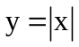 has no inverse because it is not a one to one function
i.e. for every there is not a unique . ✓ (1)

14. (7 marks)
(a)
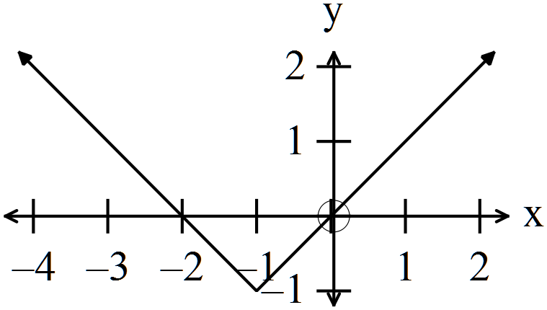
✓
✓

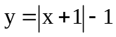

so 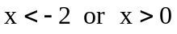 ✓ (2)

(b) Solve 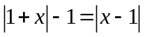
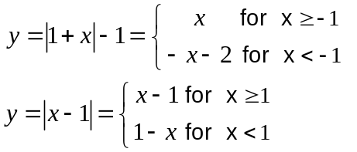
✓
✓

✓
✓

For 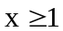
✓
✓

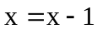 No solution
For 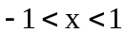
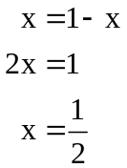
✓
✓

For 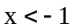
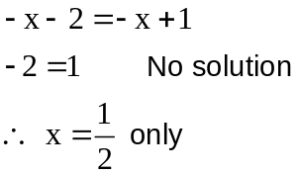
✓
✓

(5)
15. (4 marks)
✓✓
✓

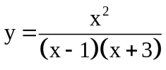
✓
✓

✓
✓

16. (5 marks)
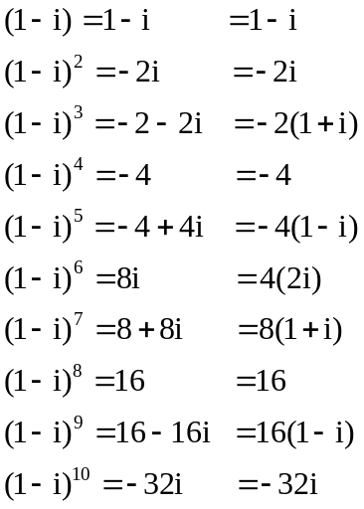 (i)

✓✓
✓

(2)

(ii) Every fourth result seems to be connected.
✓

Starting with 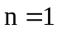, then 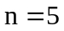, the pattern seems to be a multiple of 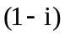.
Starting with 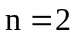, then 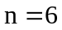, the pattern seems to be a multiple of .
Starting with 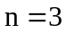, then 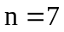, the pattern seems to be a multiple of .
Starting with 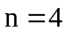, then 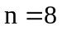, the pattern seems to be a real multiple of 4.
✓ for any one of these up to 3 marks

✓

The coefficients are a pattern of powers of 2.

A lot more analysis is needed, but this is sufficient for 3 marks.
(3)

END OF SECTION TWO

